- Ladre is a small scaled family business found in 2000s which selling computers’ hardware and software. Recently the shop owner plans to improve the business by selling the products online. He has contacted your company as a suitable software house to handle this project.
Discuss the 3 main activities that your team would perform for the architectural design of the above project.
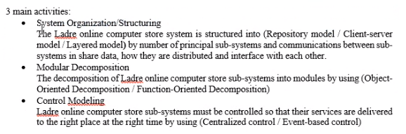

- You, as a project manager have been assigned to lead project team e-learning system for a college. The main functions of the e-learning system include programme registration and payment, on-line assessment, assignment submission, uploading and downloading course materials. The main campus of the college is located at Penang and the other branch campuses are located in Melaka, Kelantan and Sarawak.

Recommend and draw an appropriate system organization model for the above project. Explain the model and justify your recommendation.
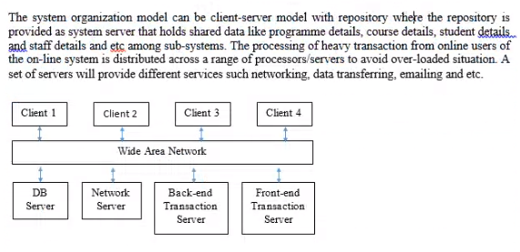

- Differentiate the following pairs of control model:

- Call-return model and manager model

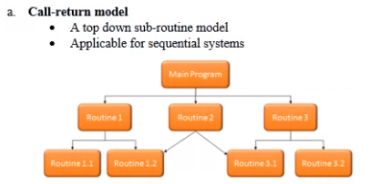
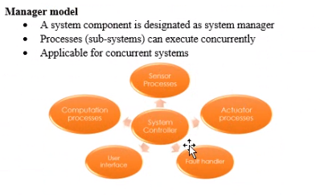
- Interrupt-driven model and broadcast model
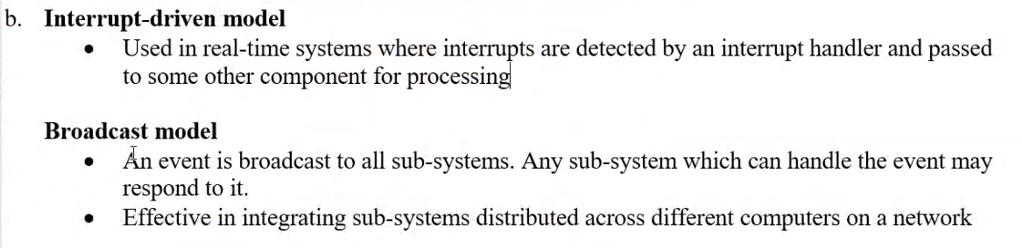
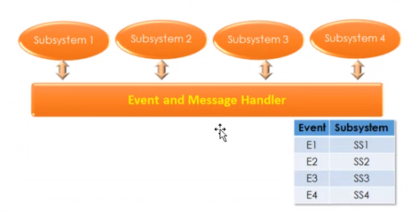

- Giving reasons for your answer, suggest an appropriate system organization model for the following systems:

- An automated ticket issuing system used by customers at a cinema.
Repository Model
- A Sales and Inventory System used by Sales Staff and Inventory Staff in an organization
Repository model or Client-Server model

- A Sales Invoicing System will firstly take the customer order transactions and itemize unit price from database, follow by totaling up all the items ordered prices to calculate the invoice amount. The system will then deduct the invoice amount with a discounted rate (if any) and this will produce the final invoice amount. Then the system will update the customer account and finally print the invoice for each customer.

Giving reasons for your answer suggest a suitable control model for the above system. You may state any assumptions to support your answer.
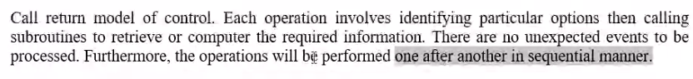

- XinJin Press is a newspaper company which started its first printed newspaper in 1960s. Recently, you are invited to attend a discussion meeting with XinJin Company’s IT department. The main agenda of the meeting is to decide on the maintenance of some of their legacy systems. One of their legacy systems is a text file storage server which stores large amount of the newspaper draft contents (original story from the interview, news draft, supporting images or news, and et cetera). The file storage system has no documentation and no proper module design. The draft contents might be useful in the future to trace the original story.

Assuming that XinJin IT department decided to re-engineer the legacy system. Propose 1 system organization/structuring design model. Explain and justify your answer.

- Easy2Study.com is a global marketplace for teaching and learning online where students are mastering their skills. The system allows the students to search, view available courses, purchase, make payment, and join the courses. An access to start the course will be given once the payment is confirmed. Easy2Study.com is planning to extend their online system on mobile platforms to attract more customers as mobile users are increasing extremely.

Suggest and explain 1 suitable system organization model and 1 control modelling model for the Easy2Study.com mobile application. Discuss your answers.
